**Cloud Computing Assignment**



**Group Members:**

**Student Name: Student Number:**

Jianyu he D17124591

Minhui Chen D17125347

Yuwei Chen D16123951

**Which Services Will You Use?**

We will use Amazon EC2, AWS EBS, ELD, Glacier, AWS CloudTrail, Amazon CloudWatch Events and SE3(Simple Cloud Storage Service) and so on.

User, Groups, And Roles

InnoMed Account

Group:

Group

Group

Group

System Administrator 1

Administrator

Monitor 1

DB Administrator 1

System Administrator 2

Monitor 2

DB Administrator 2

Monitor 3

Monitor 4

Users, Groups, and Roles

|  |  |  |
| --- | --- | --- |
| Group/Role # | Group/Role Name | Permissions |
| Group | System Administrator | All system privilege |
| Group | Data Administrator | Database all privilege |
| Group | Monitor | Full access privilege |
| Role | Administrator | All privilege |

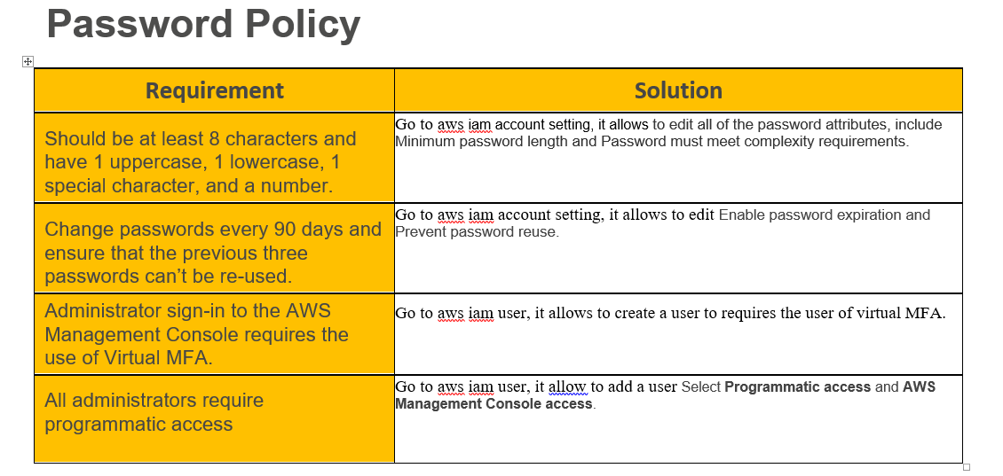

**VPC Details**

|  |  |  |  |  |  |
| --- | --- | --- | --- | --- | --- |
| VPC | REGION | PURPOSE | SUBNETS | AZS | CIDR RANGE |
| vpc-ces33er | EUROUP | Enable to launch AWS resources into a virtual network that we’ve defined. And this vpc is for euroup | 6 private subnets  2 public subnets | 2 availability zones | 10.0.0.0/224 |
| vpc-ces33ap | APAC | Enable to launch AWS resources into a virtual network that we’ve defined . this vpc is for APAC | 6 private subnets  2 public subnets | 2 availability zones | 10.0.0.0/224 |
| vpc-ces33us | US | Enable to launch AWS resources into a virtual network that we’ve defined.this vpc is for us | 6 private subnets  2 public subnets | 2 availability zones | 10.0.0.0/224 |

**Europe Subnet Detail**

|  |  |  |  |  |
| --- | --- | --- | --- | --- |
| Subnet name | VPC | SUBNET TYPE | AZ | SUBNET ADDRESS |
| publicSubnet1 | vpc-ces33er | Public | AZ1 | 10.0.0.0/24 |
| appSubnet1 | vpc-ces33er | Private | AZ1 | 10.0.1.0/24 |
| webSubnet1 | vpc-ces33er | private | AZ1 | 10.0.2.0/24 |
| DBSubnet1 | vpc-ces33er | Private | AZ1 | 10.0.3.0/24 |
| publicSubnet2 | vpc-ces33er | Public | AZ2 | 10.0.4.0/24 |
| appSubnet2 | vpc-ces33er | Private | AZ2 | 10.0.5.0/24 |
| webSubnet2 | vpc-ces33er | private | AZ2 | 10.0.6.0/24 |
| DBSubnet2 | vpc-ces33er | Private | AZ2 | 10.0.7.0/24 |

**US Subnet Detail**

|  |  |  |  |  |
| --- | --- | --- | --- | --- |
| Subnet name | VPC | SUBNET TYPE | AZ | SUBNET ADDRESS |
| publicSubnet1 | vpc-ces33us | Public | AZ1 | 10.0.8.0/24 |
| appSubnet1 | vpc-ces33us | Private | AZ1 | 10.0.9.0/24 |
| webSubnet1 | vpc-ces33us | private | AZ1 | 10.0.10.0/24 |
| DBSubnet1 | vpc-ces33us | Private | AZ1 | 10.0.11.0/24 |
| publicSubnet2 | vpc-ces33us | Public | AZ2 | 10.0.12.0/24 |
| appSubnet2 | vpc-ces33us | Private | AZ2 | 10.0.13.0/24 |
| webSubnet2 | vpc-ces33us | private | AZ2 | 10.0.14.0/24 |
| DBSubnet2 | vpc-ces33us | Private | AZ2 | 10.0.15.0/24 |

**APAC Subnet Detail**

|  |  |  |  |  |
| --- | --- | --- | --- | --- |
| Subnet name | VPC | SUBNET TYPE | AZ | SUBNET ADDRESS |
| publicSubnet1 | vpc-ces33ap | Public | AZ1 | 10.0.16.0/24 |
| appSubnet1 | vpc-ces33ap | Private | AZ1 | 10.0.17.0/24 |
| webSubnet1 | vpc-ces33ap | private | AZ1 | 10.0.18.0/24 |
| DBSubnet1 | vpc-ces33ap | Private | AZ1 | 10.0.19.0/24 |
| publicSubnet2 | vpc-ces33ap | Public | AZ2 | 10.0.20.0/24 |
| appSubnet2 | vpc-ces33ap | Private | AZ2 | 10.0.21.0/24 |
| webSubnet2 | vpc-ces33ap | private | AZ2 | 10.0.22.0/24 |
| DBSubnet2 | vpc-ces33ap | Private | AZ2 | 10.0.23.0/24 |

**Instance Detail**

|  |  |  |  |  |  |  |  |
| --- | --- | --- | --- | --- | --- | --- | --- |
| Tier | Tag* | OS | Type | Size | Justification | # of instances | User data |
| Web | Key = Name  Value = Web-tier | Microsoft Windows Server 2016 with NVIDIA GRID Driver | c5d.large | Memory: 4GB  CPU: 2 virtual cores  Storge:50 GB SSD and EBS | As required 4gb memory , 2 cpu and Microsoft Windows 2016 Base with IIS. | 1 | SSD&EBS |
| App | Key = Name  Value = app-tier | IBM WebSphere Application Server Base Edition v 8.5 on Windows | t2.xlarge | Memory: 16GB  CPU: 4 virtual cores | As required 8gb memory , 4 cpu and Microsoft Windows 2016 Base with IIS. | 1 | EBS |
| DB | Key = Name  Value = db-tier | CIS Microsoft Windows Server 2016 Benchmark Level 1 | d2.xlarge | Memory: 30.5GB  CPU: 15EC2 compute unit (4*3.75) | close to required 32gb memory, 8 cpu, 5tb storage and Microsoft Windows 2016 Base with IIS. | 1 | HDD |

**Load Balancer and Instance Security Group Detail**

|  |  |  |  |  |  |  |
| --- | --- | --- | --- | --- | --- | --- |
| Load balancer | Name* | External/internal | Subnets | SG Name* | Rule | Source |
| For web tier | Web-elb | Network load balancer | Public subnet1 | Web-elb-sg | TCP(HTTP 80) | 0.0.0.0,;;/0 |
| For App tier | app-elb | Application load balancer | Public subnet2 | App-elb-sg | TCP (HTTP 80)  TCP(HTTP 8080) | 0.0.0.0,;;/0 |

|  |  |  |  |
| --- | --- | --- | --- |
| **Instance tier** | **SG Name\*** | **Rule** | **Source** |
| **Web tier** | **Web-tier-sg** | TCP(HTTP 80) | 0.0.0.0,;;/0 |
| **App tier** | **App-tier-sg** | TCP (HTTP 80)  TCP (HTTP 8080) | 0.0.0.0,;;/0 |
| **Database tier** | **DB-tier-sg** | TCP (1433 (MS SQL)) | 0.0.0.0,;;/0 |

**Auto Scaling Launch Configuration**

|  |  |  |  |  |  |  |
| --- | --- | --- | --- | --- | --- | --- |
| Tier | OS | Type | Size | Configuration  Name* | Role | Security  Group |
| Web | Microsoft Windows Server 2016 with NVIDIA GRID Driver | c5d.large | Memory:4 GB  CPU: 2 virtual cores  Storge: 50GB SSD and EBS | WebTier | Monitor Group | web-tier-sg |
| App | IBM WebSphere Application Server Base Edition v 8.5 on Windows | t2.xlarge | Memory: 16 GB  CPU: 4 virtual cores  Storge: EBS storage only | AppTier | Monitor Group | app-tier-sg |

Auto Scaling Group

|  |  |  |  |  |  |  |  |
| --- | --- | --- | --- | --- | --- | --- | --- |
| Tier | Launch Configuration* | Group Name* | Group Size | VPC | Subnets | ELB | Tags |
| Web | webTier | webTier | 1 | Vpc-ces33er  Vpc-ces33ap  Vpc-ces33us | 10.0.2.0/24  10.0.10.0/24  10.0.18.0/24 | Web-elb | Web |
| App | AppTier | AppTier | 1 | Vpc-ces33er  Vpc-ces33ap  Vpc-ces33us | 10.0.1.0/24  10.0.9.0/24  10.0.17.0/24 | App-elb | app |

**How do you configure an account to create an audit trail for all executed API calls?**

Use CloudTrail and CloudWatch Events to monitor API calls。

**Q. Where do you save your logs?**

I will save my log in Amazon CloudWatch Logs.